Food Delivery Web Application

DESIGN DOCUMENTATION

Li Chen, Jianhui Lu, Weiran Yuan

12/10/2017

Table of Contents

1. Overview 3

1.1 Goals and Objectives 3

1.2 The Assumptions and Constrains 3

1.3 Product context 4

1.4 Core Features 4

2 Data Design 4

2.1 Internal Software Data Structure 4

2.2 Global Data Structure 5

2.3 Temporary Data Structure 5

2.4 Database Description 6

2.5 System architecture 7

3. Component-Level Design 8

3.1 System structure 8

3.2 Classes design 8

4. User Interface Design 14

4.1 Description of the user interface 14

4.2 objects and actions 14

4.3 interface description 14

5. implemented interface 19

# Overview

The purpose of this design documentation is to provide a primary description about our Food-Delivery Website, showing the deep insight of our internal and external structures. The following topics are going to be discussed in this documentation:

* The design and development environment
* Data construction, transportation and storage.
* Design assumptions and constrains
* Algorithm models.
* User interface design
* Test cases and expected results.]

## 1.1 Goals and Objectives

The goal of our project is to develop a 3-tier web application, which includes the cooperate of browser, server and database, using what we covered in Software Development class and online resources.

The content of our project is to develop a food order-and-delivery website, allowing customers reach food and restaurants franchising. This product offers more choices and better comparison of restaurants for customers, and large advertising and consuming platform for restaurants.

## 1.2 The Assumptions and Constrains

There are several assumptions and constraints that are of importance for the project.

Important assumptions:

* Our team can refer, use and modify all resources we have access to, including course materials, online examples;
* Members have software development experience and are able to work efficiently together;
* Our members can play clients’ role and provide revise advices during the implementation process;

Main constrains:

* Additional financial sponsors are not available in this project.
* The individual working hours would be limited to 10 hours per week during this semester.
* Frequent group meeting may be not available for each week.
* Although group members can give feedback as clients, there’s insufficient customer involvement in our developing and maintaining process.

## 1.3 Product context

The Food-Delivery website will be able to offer customers to view dozens of restaurant, choose one of them to view and order food. And restaurant that franchises this website could receive and manage orders on their end.

## 1.4 Core Features

Customer Welcome and Signup

* Appears when account is needed to create.
* Allows user to register and add information to database

Customer Login

* Appears when users click login button or users check out their shopping cart.
* Allow users to change their personal information

Restaurant View and Menu View

* Firstly, users can see a list of restaurant and choose one of them.
* After choosing restaurant, users can see the menu of chosen restaurant with different categories.

Add Food to Shopping Cart

* Customers can add food to their shopping cart
* The shopping cart automatically calculates tax and tips and shows total price and

Customer Place Order

* Allow customer to input their name, phone number and delivery address,
* Allow customer to use on line payment method.

Restaurant Receive Order Notifications

* Allow restaurant to view newly orders
* Allow restaurant to manage orders (cancel, finish)

# Data Design

## 2.1 Internal Software Data Structure

Internal structure of our product could be divided into two parts: server side and client side.

On the client side, data could data will reside locally in memory and will be organized based on the classes defined later in this document. Since the program may be considered data-centric, the classes that handle the data will be isolated and will be accessed by way of a Model-View- Controller system. The data on the local Android client will be requested from the server at application initialization and refreshed as necessary based on user actions.

The data structure on the server will essentially mirror the structure of the local Android client in terms of member fields of the classes. The server will be implemented using PHP. Permanent storage of user information will be accomplished.

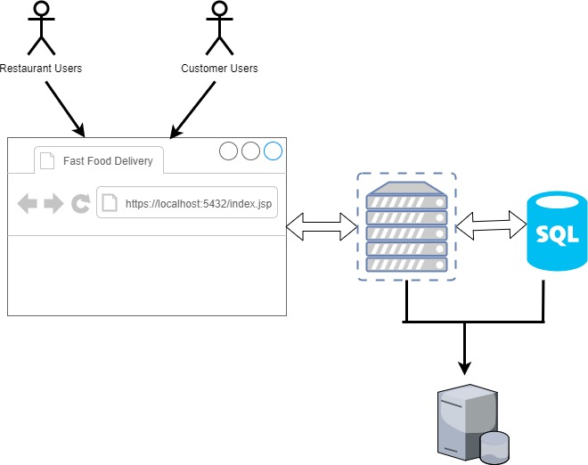

## Global Data Structure

The global data structure of this web application could be best characterized by the database. Here we used relational database model to store our customer, restaurant and order information. The client-side browser would never have directly access to our database, they interact with our database through our server.

## 2.3 Temporary Data Structure

Temporary data structures are the data that create locally on clients’ end, as they related to our web application. This data would exist only for their duration time.

## 2.4 Database Description

--- TABLE structure for restaurant

CREATE TABLE restaurant(

id INT,

name VARCHAR(255),

password VARCHAR(255),

deliver_fee FLOAT,

PRIMARY KEY (id)

);

--- TABLE structure for restaurant menu

CREATE TABLE dishes(

id INT,

name VARCHAR(225),

restaurant_id INT,

price FLOAT,

description TEXT,

PRIMARY KEY (id)

);

--- TABLE structure for customer

CREATE TABLE customer(

id INT,

username VARCHAR(255),

password VARCHAR(255),

first_name VARCHAR(255),

last_name VARCHAR(255),

phone VARCHAR(12),

PRIMARY KEY (id)

);

--- TABLE structure for order information

CREATE TABLE order_info(

order_num INT,

customer_id VARCHAR,

restaurant_id VARCHAR,

restaurant_state VARCHAR(255),

customer_state VARCHAR(255),

PRIMARY KEY(order_num)

);

--- TABLE structure for order detail

CREATE TABLE order_item(

order_num INT,

dish_id INT,

restaurant_id INT,

amount INT

);

# 3. Component-Level Design

## 3.1 System architecture

Our web application could be broken up into two major component: a client-side JSP application and server-side PostgreSQL database.

The client-side application is a combination of two parts: the functional component (implemented in Java programing) and the graphical component implement by JSP and servelet. The function component forms the core of our food-delivery application, since they 1) give customer an overview of menu and selection of foods, 2) give restaurant access to manage their on-line data. The graphical component, as the name implies, is simply the graphical user interface. It provides all of the buttons, text boxes, and other on- screen elements which allow the user to access all of the features provided by the application.

The server component is comprised of a Java program, which includes work flows, data request and response.

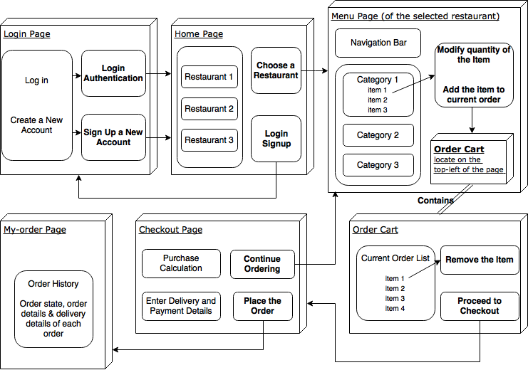

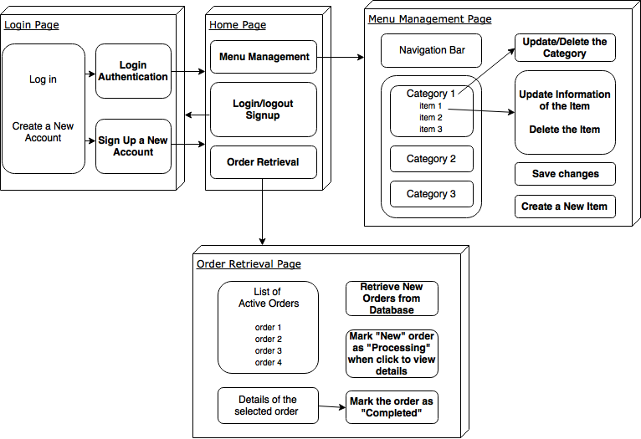

## 3.2 Classes design

3.2.1 Use case diagram:

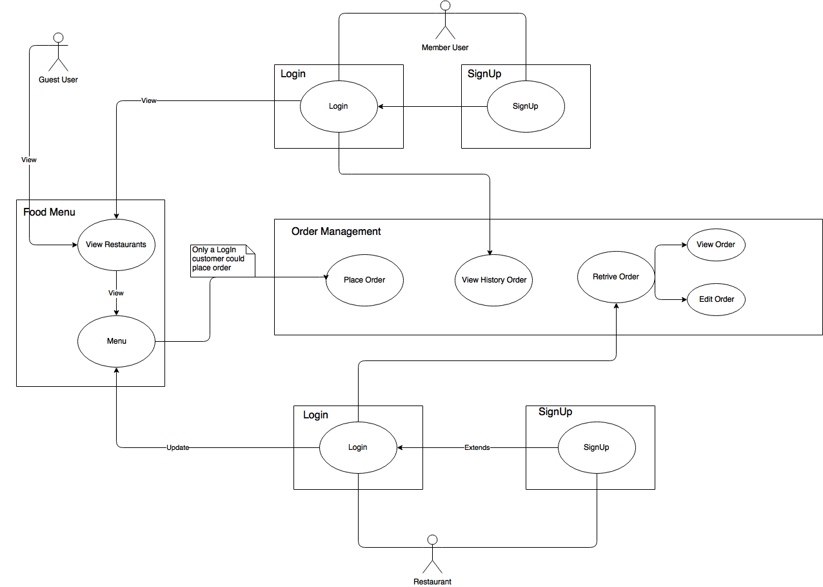

3.2.2 component diagram

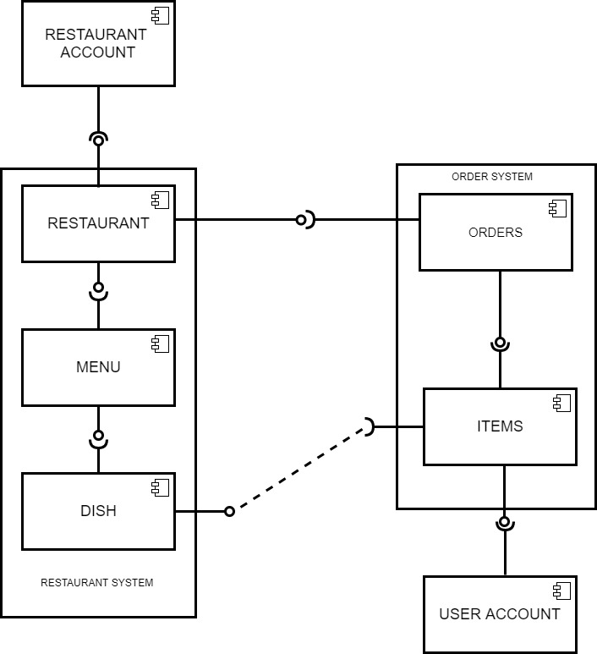

3.2.3 UML class diagram (for view menu process)

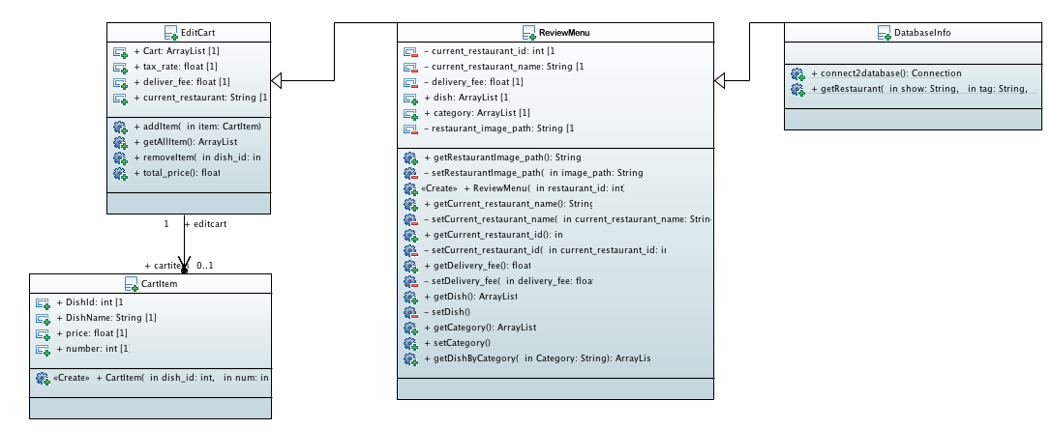

3.2.4 UML class diagram (for place order process)

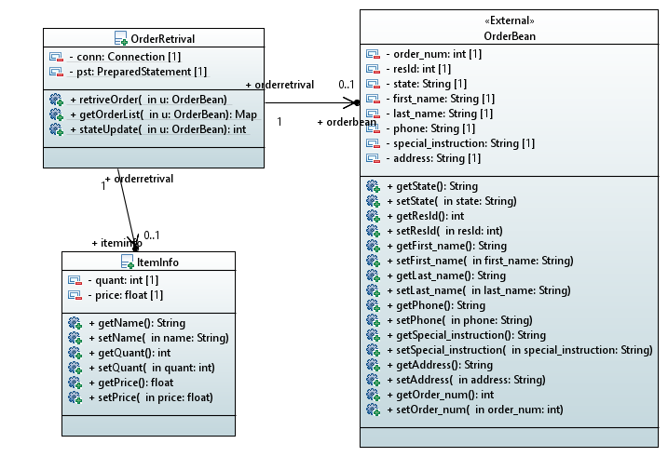

3.2.5 Sequential diagram









3.2.6 Data diagram



3.2.7 Deployment diagram

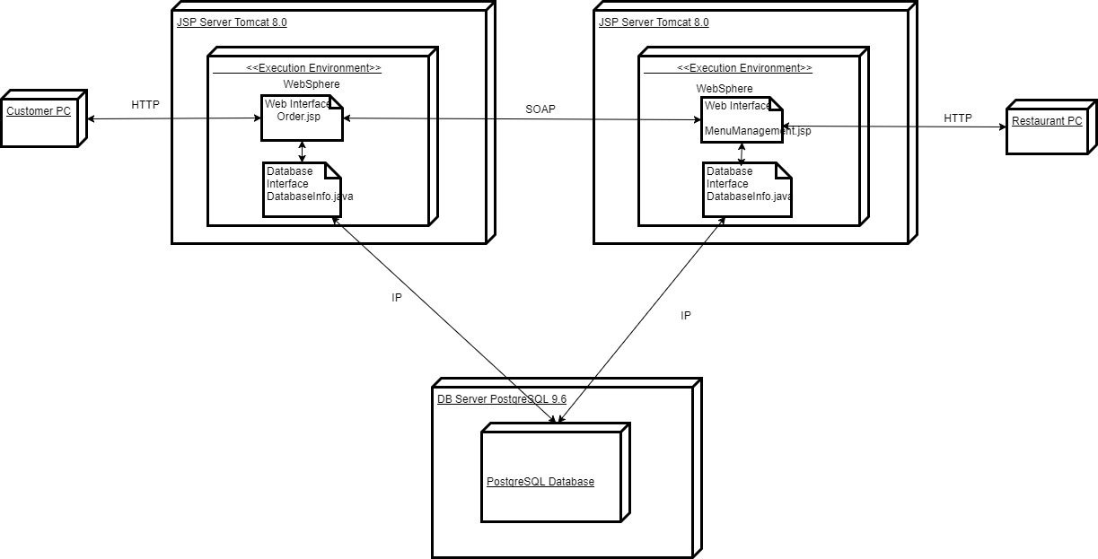

# 4. User Interface Design

## 4.1 Description of the user interface

Each menu will consist of various GUI components, such as buttons, labels, text fields, and list objects. These components will be arranged in such a way that the user will be able to quickly grasp the purpose of each menu and perform whatever task it is designed for efficiently. A detailed description of these menus and their interactions with each other will be described in section 4.1.2

## 4.2 objects and actions

For first-time users

* welcome page
* view menu
* sign up

For returning users

* Welcome,
* View menus
* Log in
* View history

## 4.3 interface description

welcome page

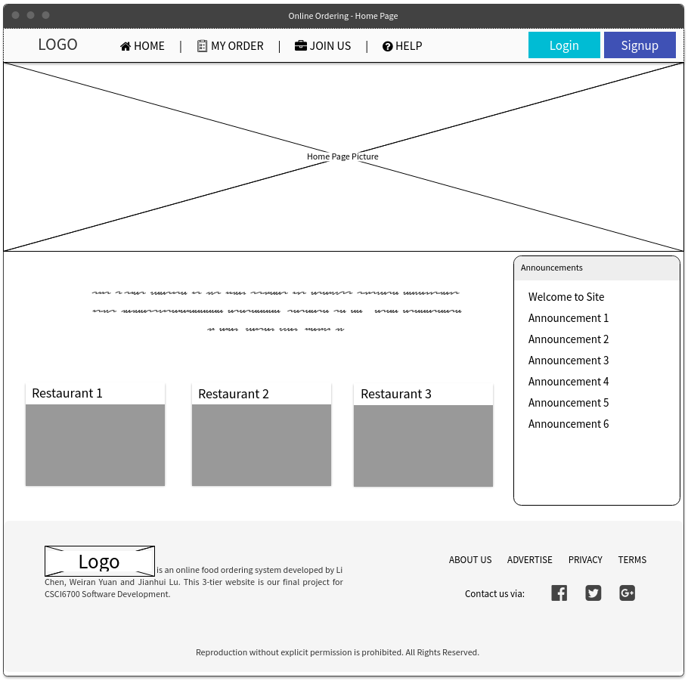

customer-side menu view

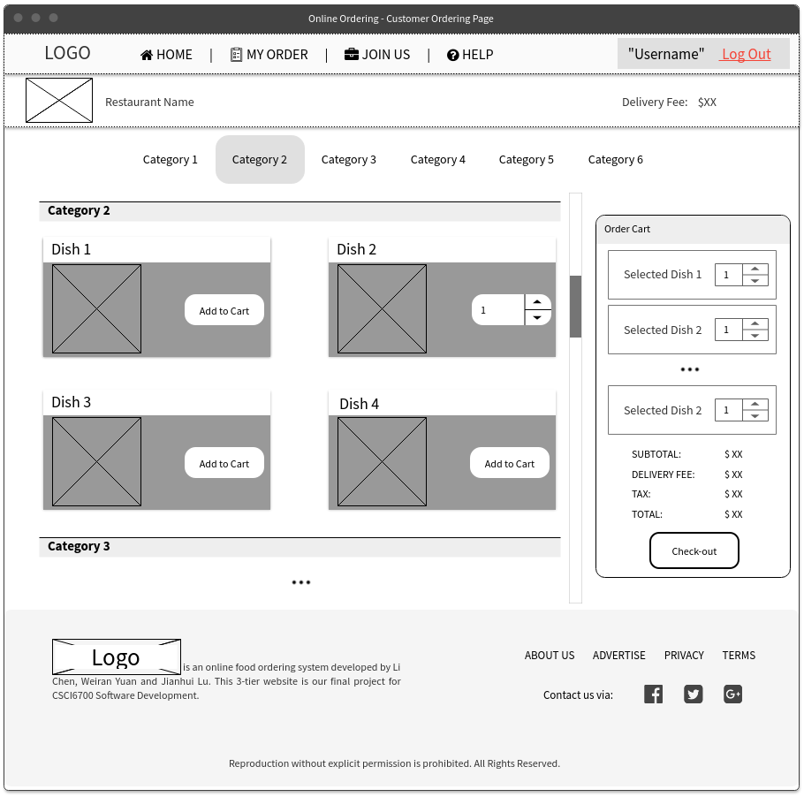

customer-side order submission

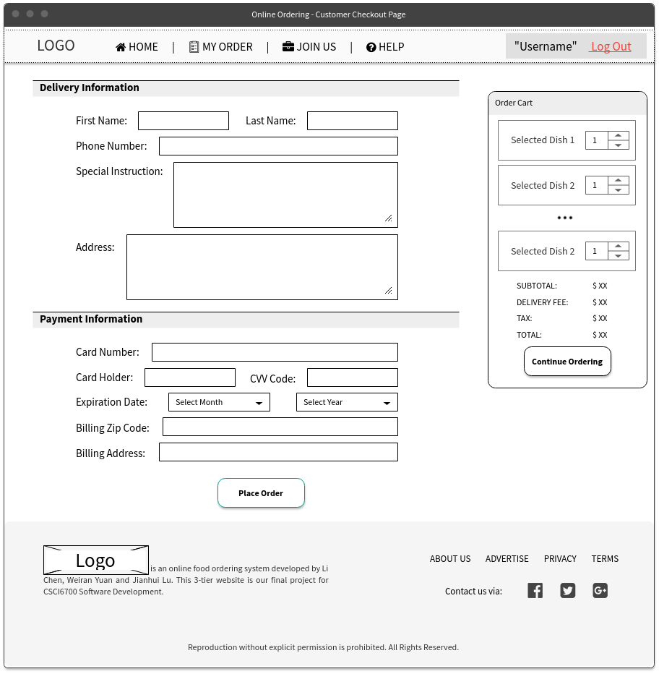

restaurant-side menu management

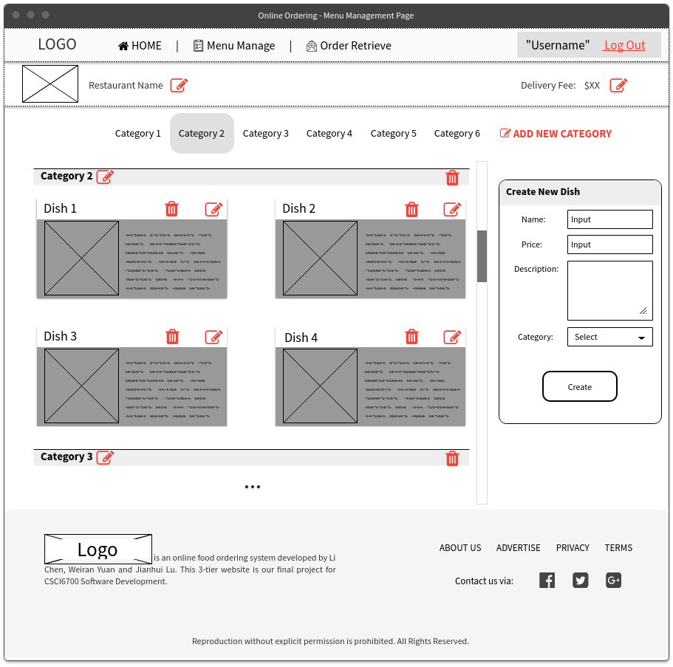

restaurant-side order management

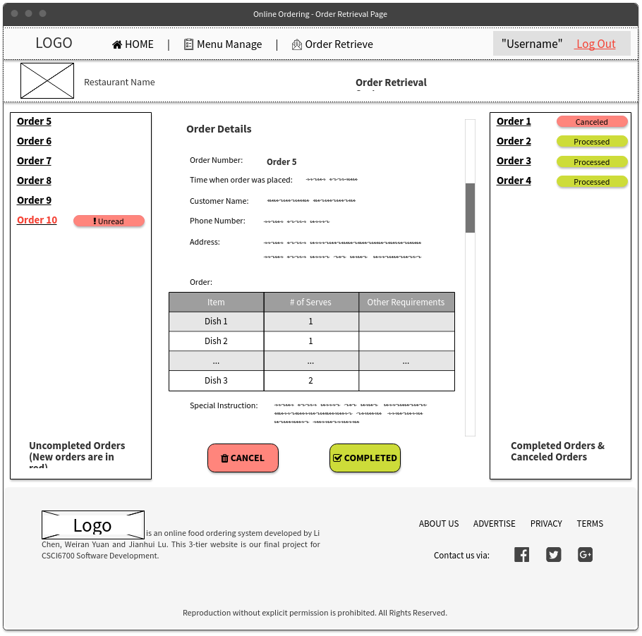

# 5. implemented interface

Login Page

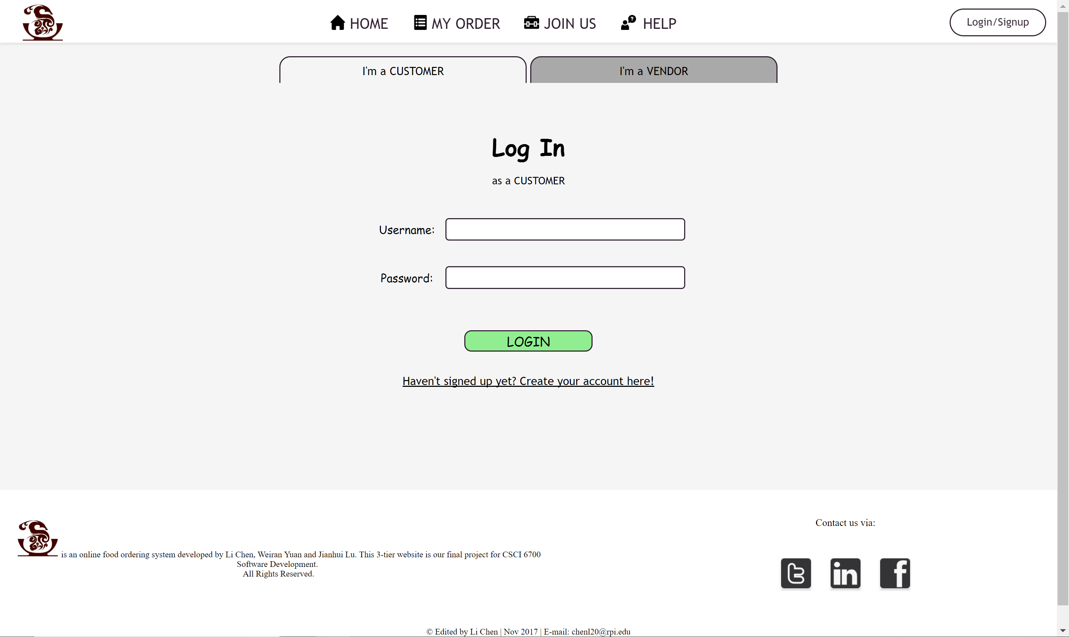

Sign Up Page

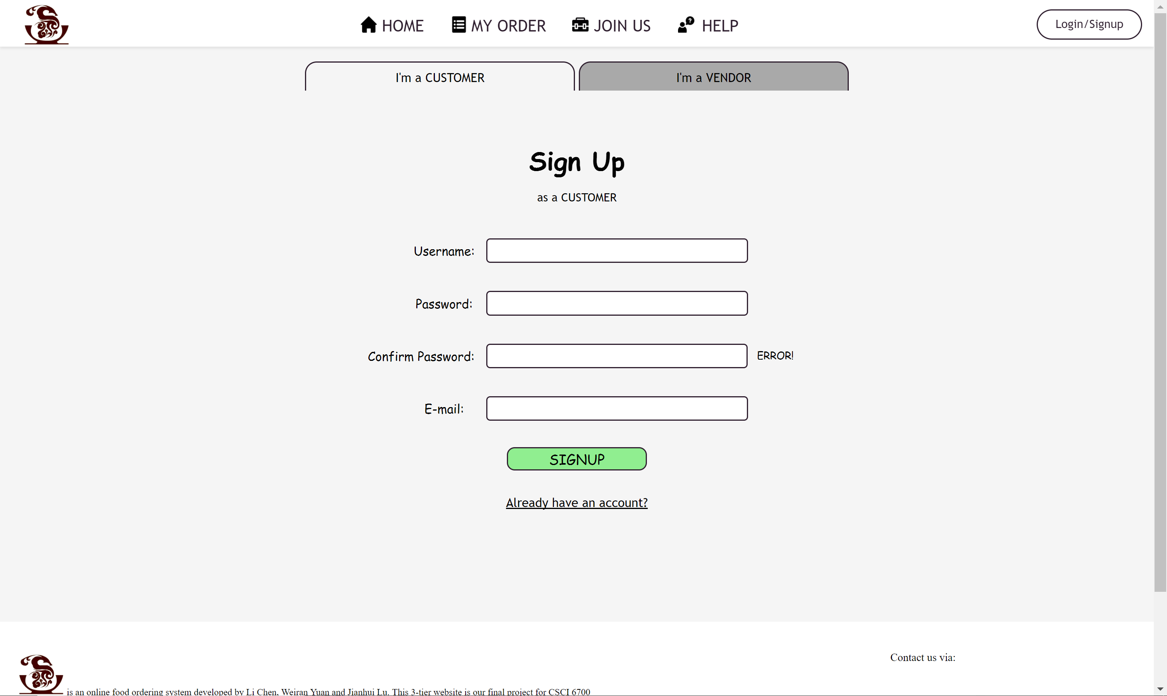

Welcome Page

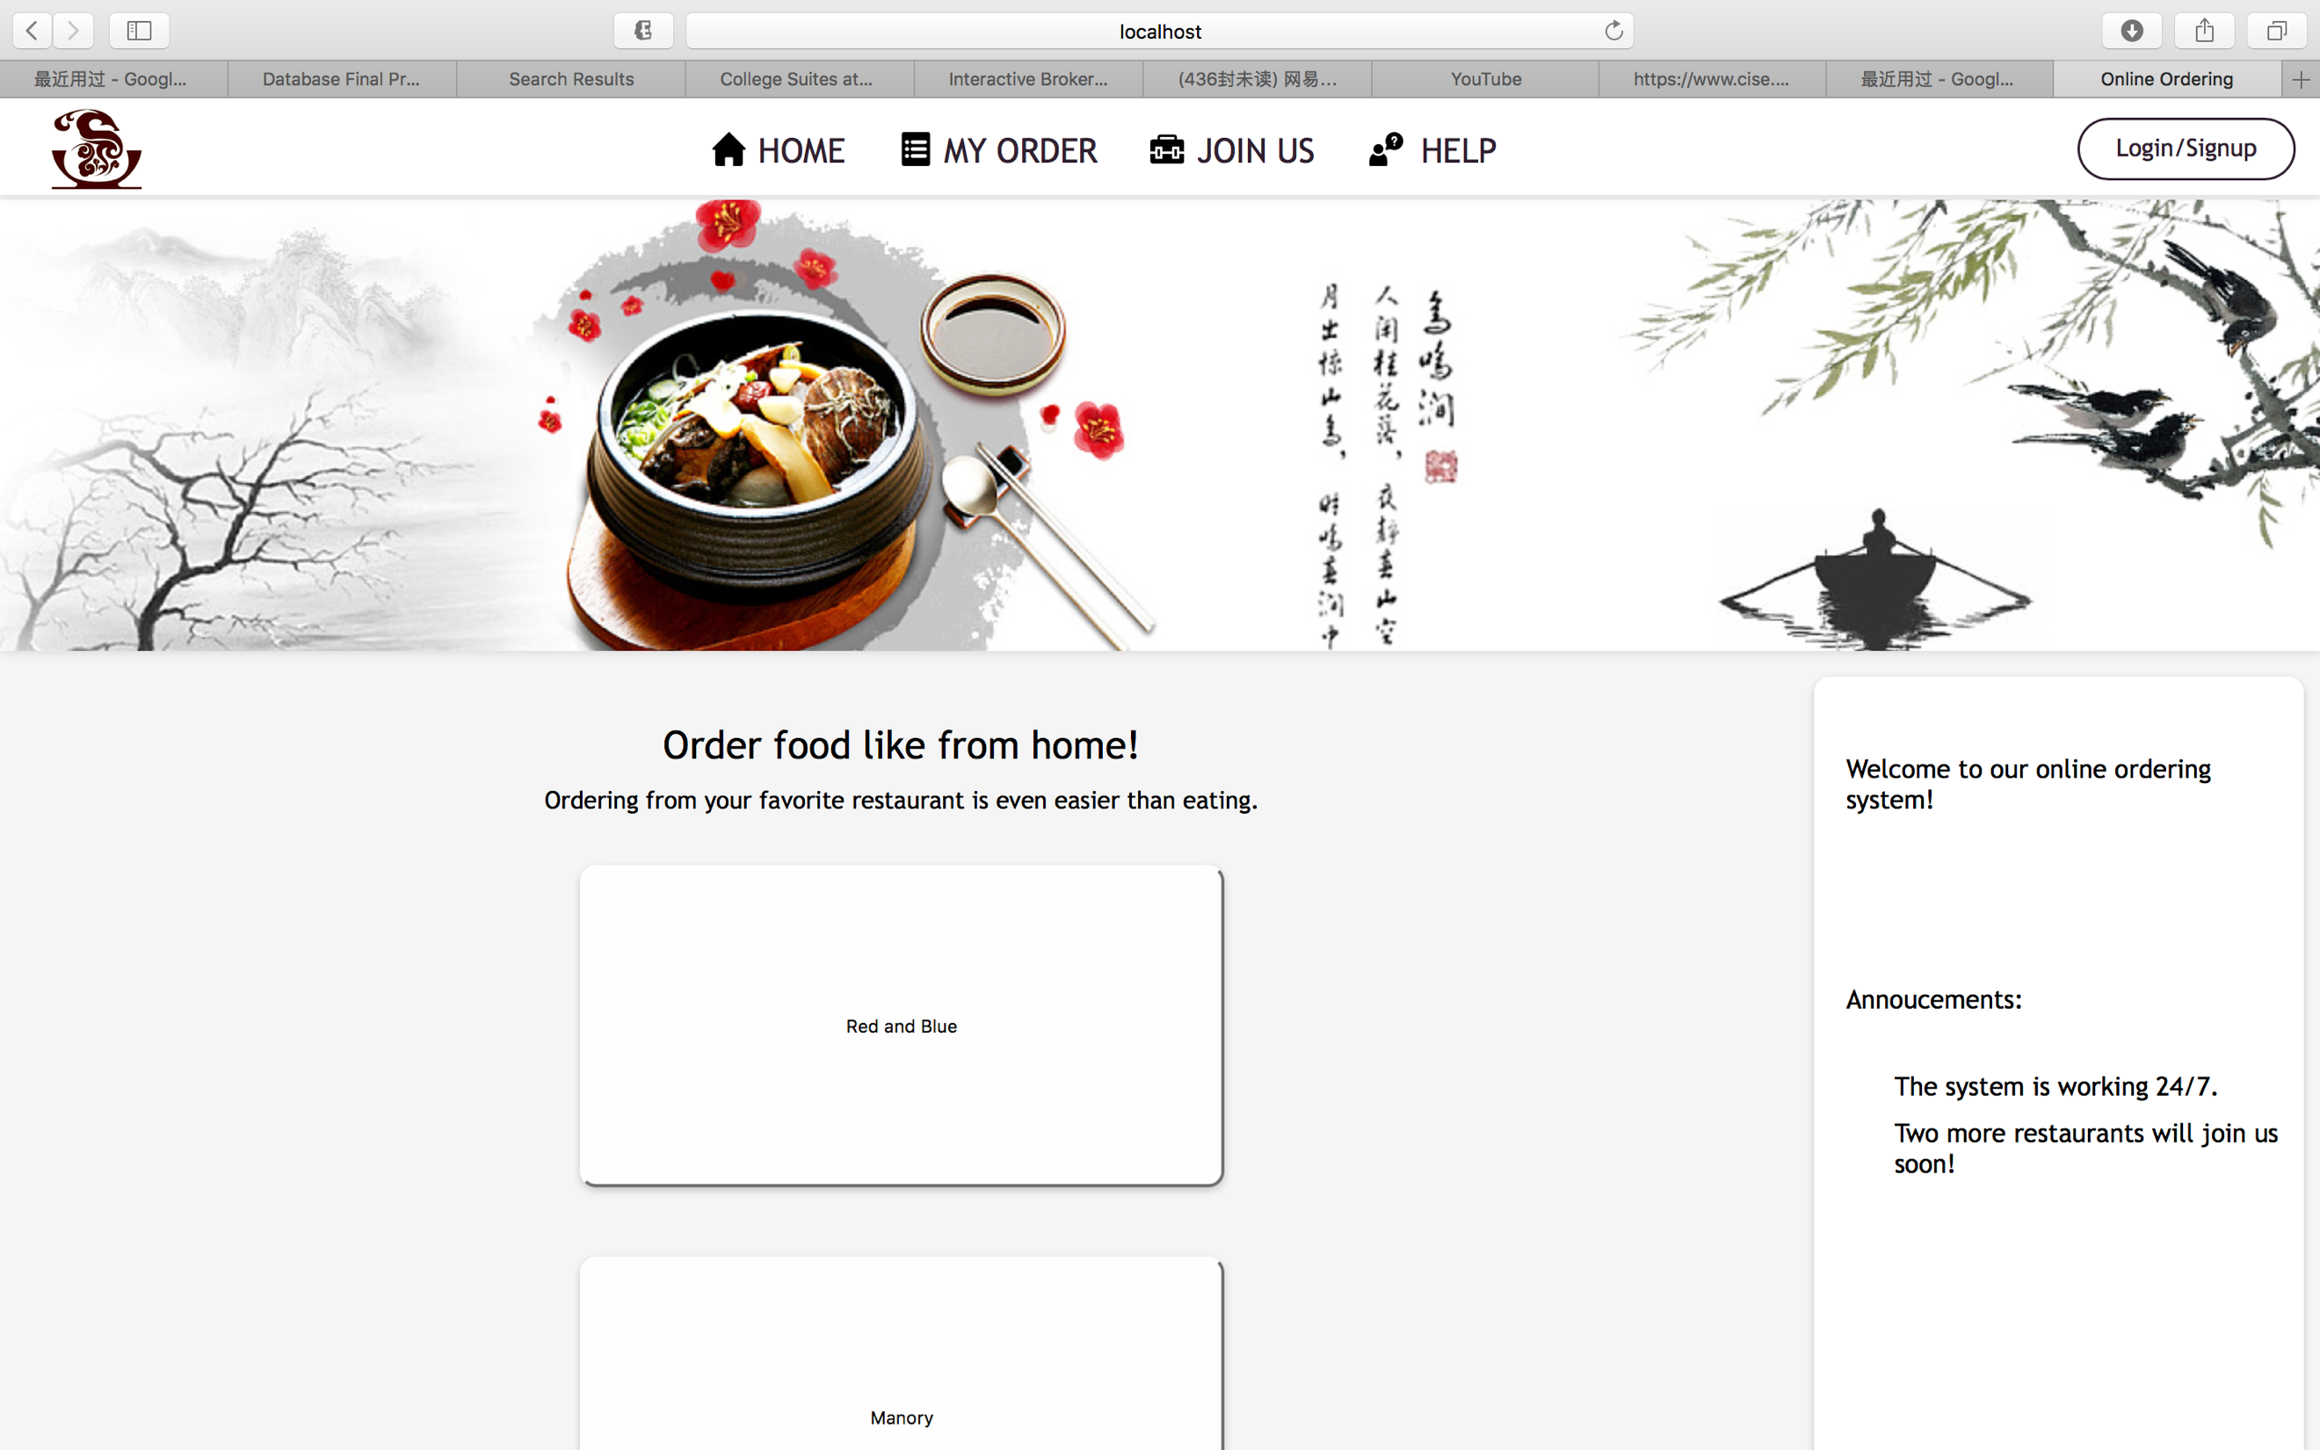

Menu View & Add Cart Page

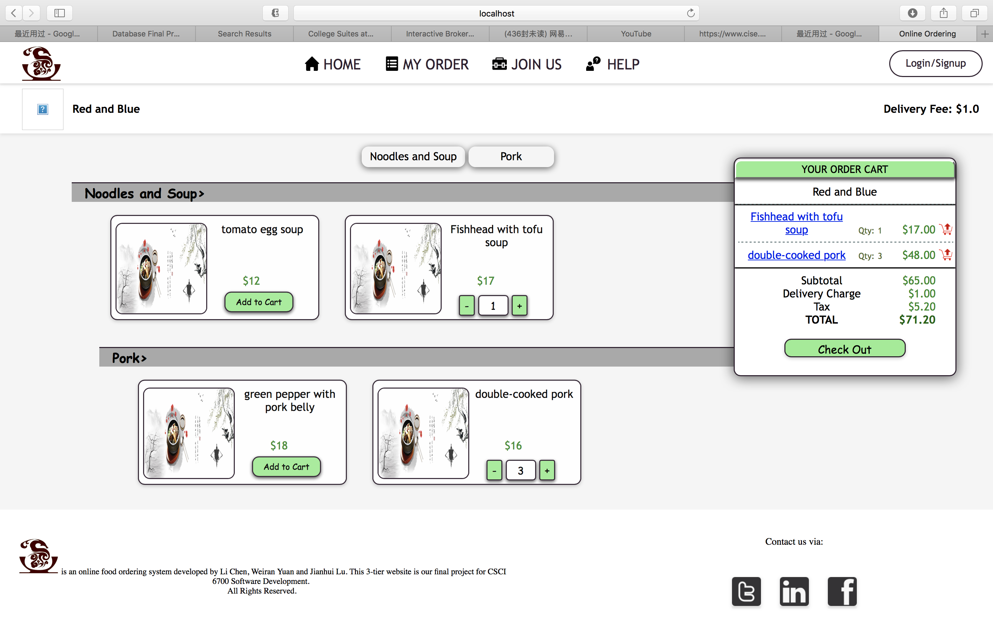

Place Order Page

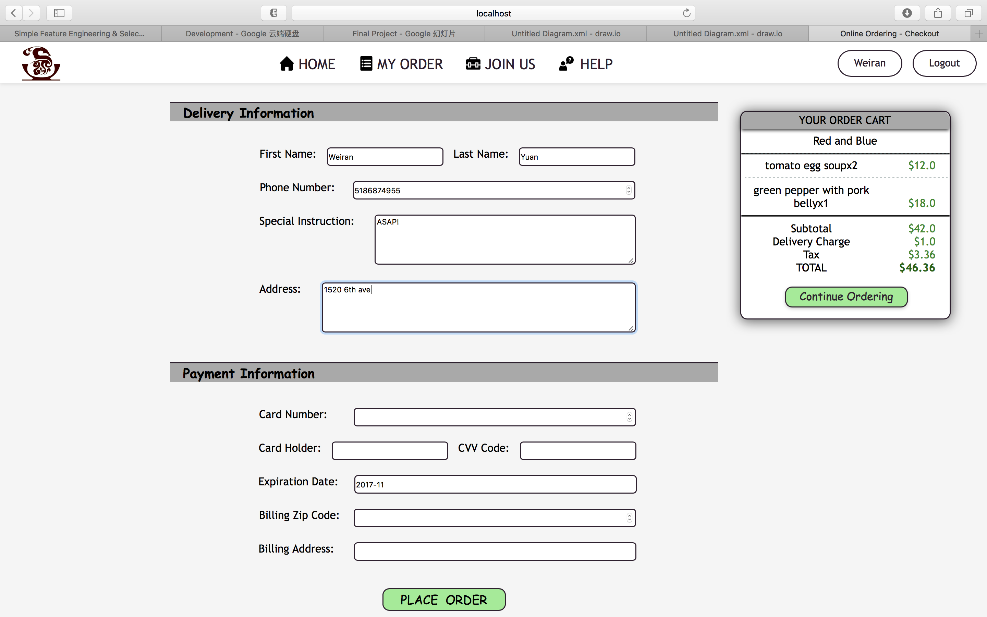

View History Order Page

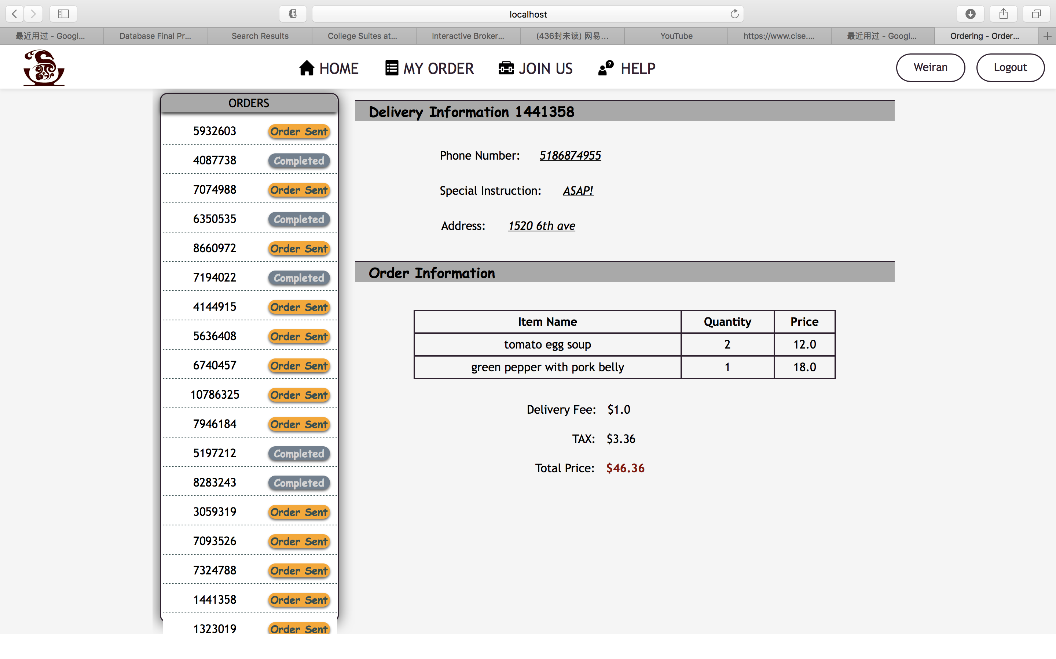

Restaurant-side Manage Order Page

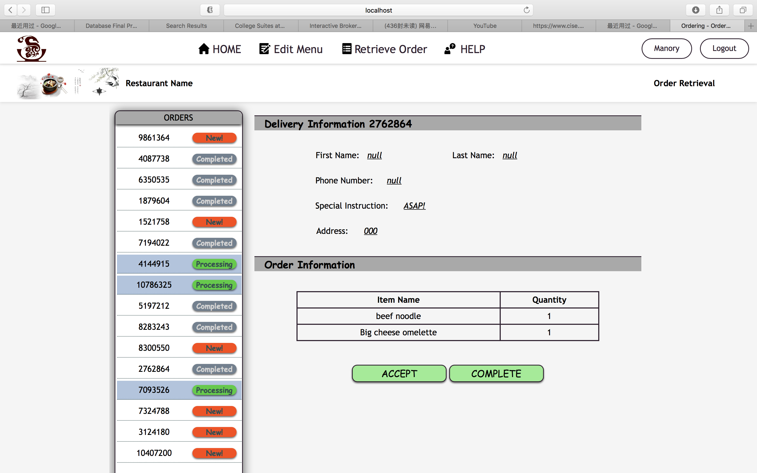

Restaurant-side Update Menu Page

